What is natural selection?

1. Summarize what you already know about natural selection.

We will begin to answer this question by analyzing the changes in a population of mice that lived in a desert with gray sand. These drawings show how the population changed from time 1 to time 3.
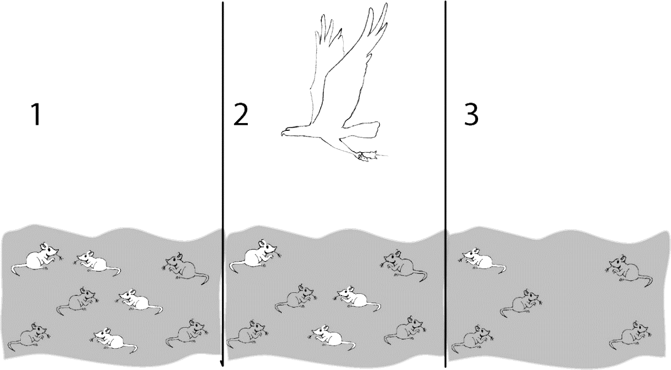

2a. Describe how the population of mice was different at time 3 compared to time 1.

2b. Explain what happened to cause this difference.

3a. Suppose the mice in drawing 3 had babies. What color fur do you think most of the babies would have?

3b. Explain your reasoning.

4. Fitness is defined as the ability to survive and reproduce. For the mice in the figure, which characteristic increased fitness?

5. The term fitness can have different meanings, depending on what subject you are discussing.

What does the term physical fitness mean?

What does the term fitness mean when biologists are discussing evolution?

Three pairs of adult mice were released in a gray sand desert; these Generation 1 Adults are shown in the first row of the chart. These mice had the Generation 2 Babies shown in the second row. The babies that survived to become adults are shown in the last row.

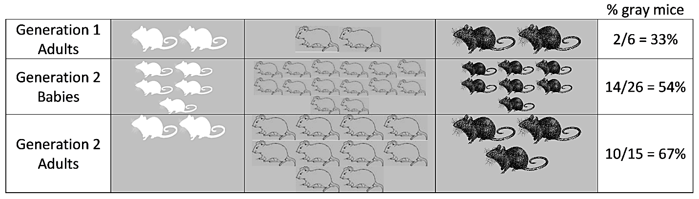

This table shows some characteristics of the Generation 1 adult females.

 | White Fur | Gray Fur | Black Fur
Number of babies born | 5 | 14 | 7
Age at death | 3 months | 6 months | 4 months

6. Give a likely explanation for why the female with gray fur had the most babies.

- A heritable trait is a characteristic that is influenced by genes and passed from parents to offspring. For example, fur color is a heritable trait for mice.
- An adaptation is a heritable trait that increases fitness (the ability to survive and reproduce).

7a. Which color fur is an adaptation for the mice in the gray sand desert?

7b. What evidence supports your answer?

8a. The percent of adults with gray fur increased from 33% in Generation 1 to 67% in Generation 2. What caused this increase?

8b. Predict what would happen to this population of mice after many generations on the gray sand.
- About two-thirds (67%) of the mice would have gray fur.
- Almost all of the mice would have gray fur.
- There would be equal numbers of mice with white fur, gray fur, and black fur.

8c. Explain your reasoning.

9a. Suppose that six of the Generation 2 adults migrated to a nearby desert with white sand. Suppose that these six mice included a pair of white mice, a pair of gray mice, and a pair of black mice. What would this population of mice on the white sand desert look like after many generations? 1/3 with each color fur ___ mostly gray mice ___ mostly white mice ___

9b. Which color fur would be an adaptation for mice on the white sand?

10. Give an example to illustrate that a characteristic that is an adaptation in one environment may not be an adaptation in a different environment.

11. Explain how an adaptation becomes common in a population. (Remember that an adaptation is a heritable trait that increases fitness.)

This process is called natural selection. A heritable trait that increases fitness tends to become common in a population because:
- Individuals that have this trait are more likely to survive and reproduce.
- Offspring generally have the same trait as their parents.

12a. Natural selection affects many types of heritable characteristics. This table shows the effects of two alleles of a gene that influences female reproduction, but does not affect mortality. (Both types of mice survive for six months, on average.)

Allele | Average Number of Litters in Six Months | Average Number of Babies per Litter
R | 3 | 4
r | 2 | 3

Which allele would be favored by natural selection? R ___ r ___

12b. Explain your reasoning.

13a. Evolution is defined as a change over time in the inherited characteristics of a population. What is evolution by natural selection? (A complete answer will include adaptations, fitness and heritable.)

13b. Explain why organisms have many characteristics that help them survive and reproduce in their environment.

Necessary Conditions for Natural Selection
You will analyze three hypothetical scenarios in order to learn about the conditions that are needed for natural selection to occur.

14a. Suppose that all the mice that migrated to the desert with white sand had gray fur. Would you expect natural selection for fur color to occur in this population of mice? yes ___ no ___

14b. Explain why or why not.

14c. Use this example to explain why evolution by natural selection can only occur if there is variation in a trait.

Now, suppose that a pair of white mice, a pair of gray mice, and a pair of black mice migrated to a desert with white sand. The owner of this desert had a special fondness for mice, so she had eliminated all of the predators that ate mice. Therefore, white, gray and black mice all had the same probability of surviving and reproducing.

15a. Would the proportion of white mice increase in the next generation? yes ___ no ___

15b. Explain your reasoning.

15c. Based on this example, explain why evolution by natural selection can only occur if the variation in a trait results in differences in fitness.

Next, suppose that a pair of white mice, a pair of gray mice, and a pair of black mice migrated to a desert with black sand. The owner of the black desert dyed the fur of all six mice black, so they would all be equally well camouflaged.

16a. Think about the Generation 2 Babies of these Generation 1 Adults. What proportion of the babies do you think would be born with black fur?
about 33% ___ about 67% ___ at least 90% ___

16b. Explain your reasoning.

17. Explain why evolution by natural selection only occurs if variation in a characteristic is heritable.

Notice that natural selection does not refer to any individual changing its characteristics. Rather, natural selection results in changes in the proportion of the population that has a heritable characteristic that influences fitness.

18a. Natural selection occurs in all types of organisms. What is the adaptation in the example of natural selection shown in these pictures?

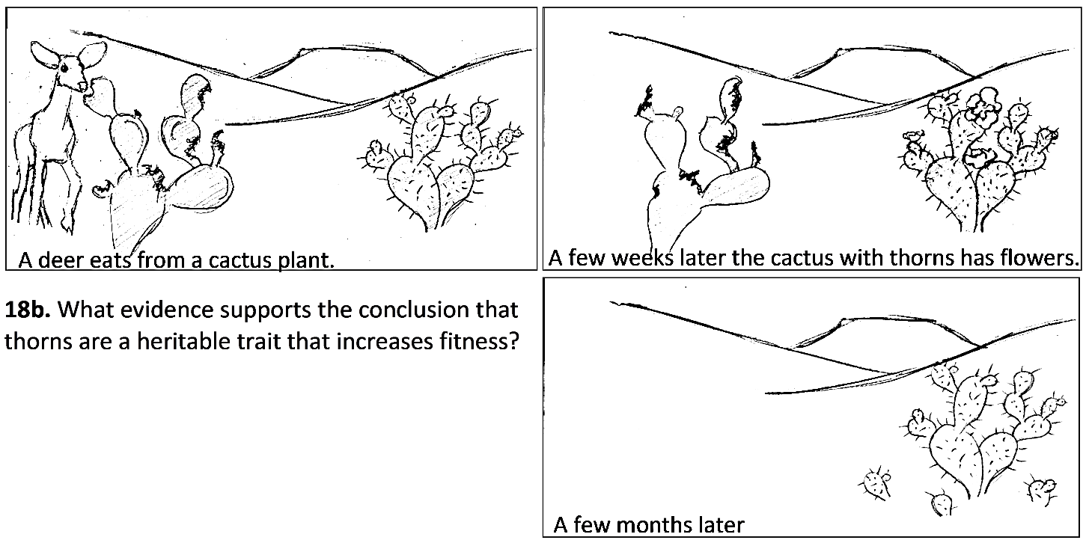

18c. Complete the following table to describe the conditions needed for natural selection to occur and the evidence that the cactus example meets these conditions.

Condition Needed for Natural Selection to Occur | Evidence from the Pictures that this Condition is True in the Cactus Example

By Dr. Ingrid Waldron, Dept Biology, University of Pennsylvania. © 2022. This Student Handout and Teacher Preparation Notes with instructional suggestions and biology background are available at https://serendipstudio.org/exchange/bioactivities/NaturalSelectionIntro.

